**Classification – Grid Search CV Documentation**

1.Identify your problem statement

Stage 1-Machine Learning

Stage 2-Supervised Learning

Stage 3-Classification

2. Tell basic info about the dataset (Total number of rows, columns)?

399 rows and 25 columns

3.Mention the pre-processing method if you’re doing any (like converting string to number – nominal data)

I have used **One Hot Encoding,** pre-processing method toConvert string to number(nominal data)

**Pc , pcc, ba, htn, dm, cad, appet, pe, ane, classification,** these columns are changed by using this Pre-Processing method

**Documentation Of Machine Learning Classification Algorithm:**

**Bernoulli Naïve Bayes:**

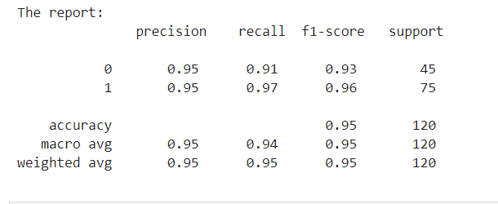

**roc_auc_score :**



**Categorical Naïve Bayes:**

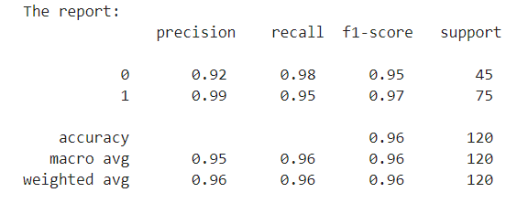

**roc_auc_score :**



**Complement Naïve Bayes:**

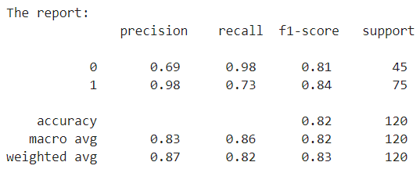

**roc_auc_score :**



**Decision Tree :**

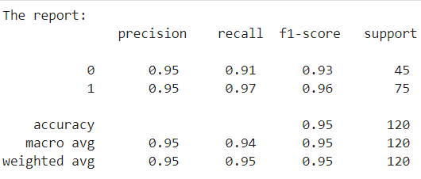

**roc_auc_score :**



**Gaussian Naïve Bayes:**

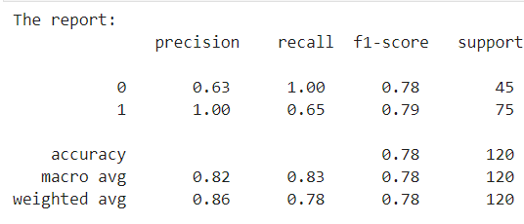

**roc_auc_score :**



**K Nearest Neighbors :**

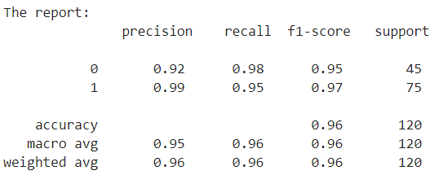

**roc_auc_score :**



**Logistic Regression :**

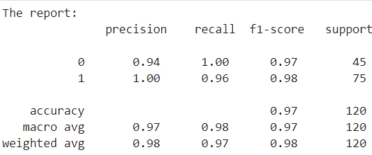

**roc_auc_score :**



**Multinomial Navie Bayes:**

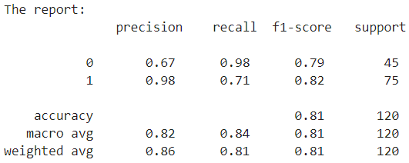

**roc_auc_score :**



**Random Forest :**

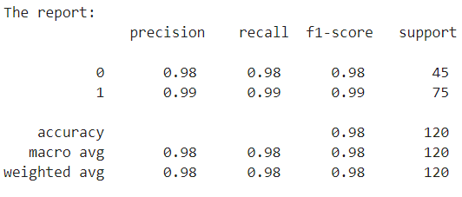

**roc_auc_score :**



**Support Vector Machine:**

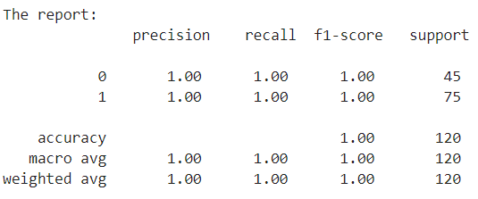

**roc_auc_score :**



**Support Vector Machine Classification is the final model I Choose . Because It has Higher Accuracy Value when Compared to all the above 10 Models.**

**The Hyper Tuning Parameters of SVC Algorithm which Gives Higher Accuracy of 1.0 is 'C': 10, 'decision_function_shape': 'ovo', 'gamma': 'scale', 'kernel': 'poly' .**